

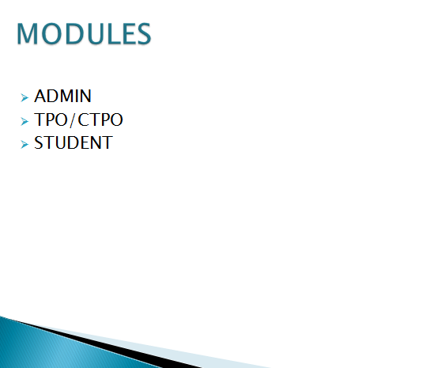

Home Page





About page

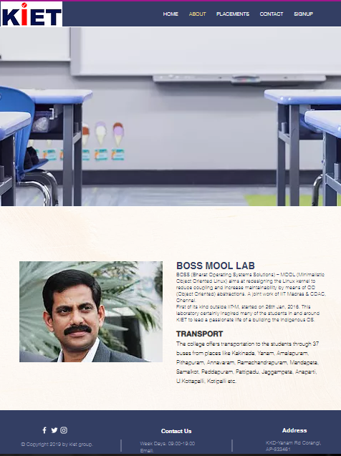

Placements Page



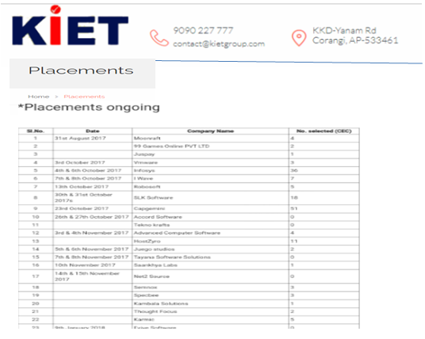

Contact Page

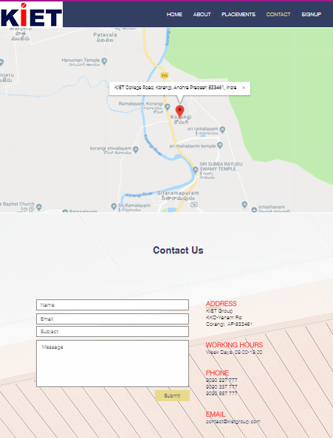

Signup Page

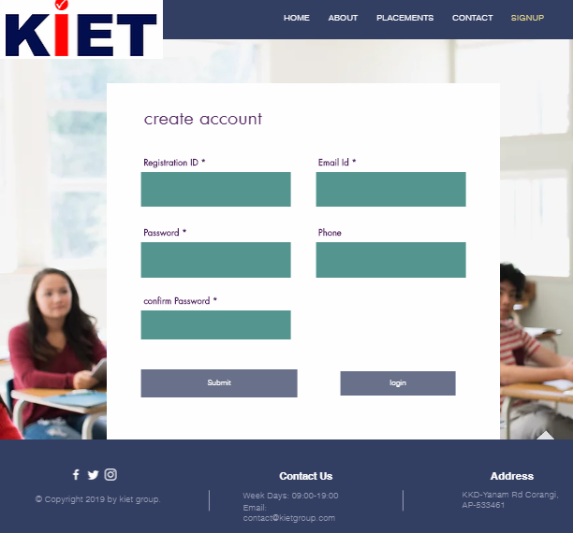

Student Registration Form

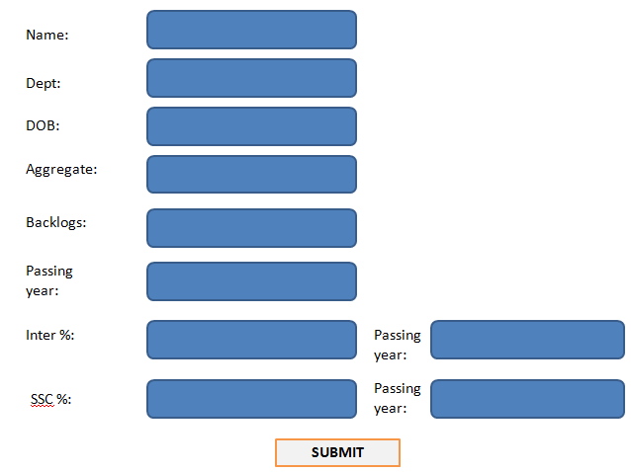

Login Page

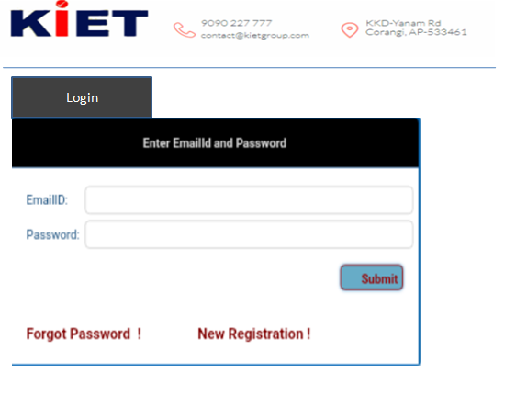

Student Dashboard

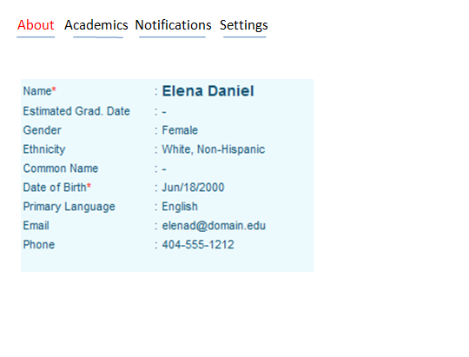

Admin Dashboard

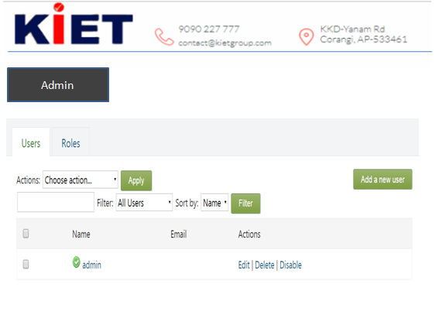

**TPO Dashboard**

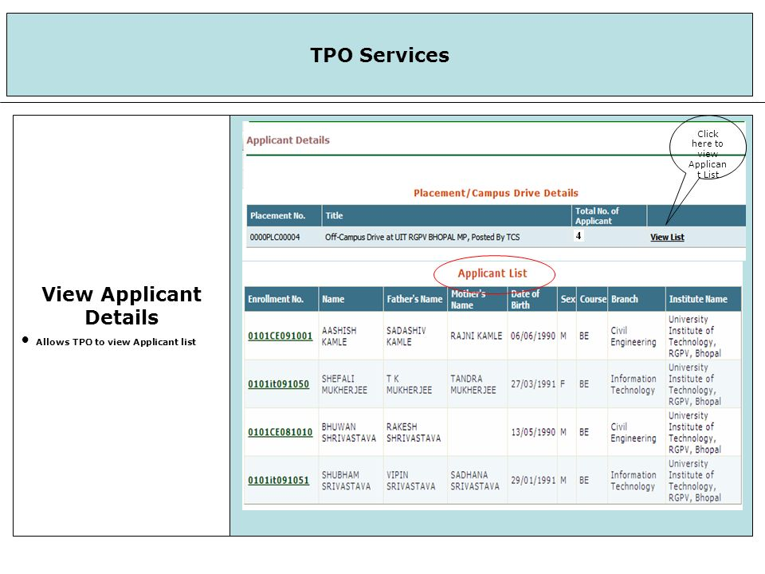

**DATABASE SCHEMA**

**Registration Table**

|  |  |  |  |
| --- | --- | --- | --- |
| **S.NO** | **Attributes** | **Data Type** | **NULL** |
| 1 | Id(Primary) | Varchar | No |
| 2 | Name | String | No |
| 3 | Branch | String | No |
| 4 | Email id | Varchar | No |
| 5 | DOB | Date | No |
| 6 | Contact No | Numeric | Yes |
| 7 | Qualification Level | Varchar | No |
| 8 | Education specification | Varchar | No |
| 9 | Aggregate | Float | No |
| 10 | Backlogs | Numeric | Yes |
| 11 | Passing year | Date | No |
| 12 | Password | Varchar | No |
| 13 | Confirm password | Varchar | No |

**Drive Table**

|  |  |  |  |
| --- | --- | --- | --- |
| **S.NO** | **Attributes** | **Data Type** | **NULL** |
| 1 | Company name | string | No |
| 2 | profile description | Text | No |
| 3 | Eligibility criteria | Varchar | No |
| 4 | Year of passing | Date | No |
| 5 | Package | Varchar | No |
| 6 | Date of Drive | Date | No |
| 7 | Job location | String | No |
| 8 | Official email | Varchar | No |
| 9 | On/off campus | String | No |
| 10 | No of rounds | Numeric | No |
| 11 | Type of offer | String | No |
| 12 | Registration link | Varchar | No |
| 13 | Registration close | Date | No |
| 14 | Drive Incharge | String | No |
| 15 | Min no of students required | Numeric | No |

**Placement Table**

|  |  |  |  |
| --- | --- | --- | --- |
| **S.NO** | **Attributes** | **Data Type** | **NULL** |
| 1 | Company Name | String | No |
| 2 | No. of Students Attended | Numeric | No |
| 3 | No. of Students Placed | Numeric | Yes |
| 4 | Average package | Numeric | No |

**DEMO WEBSITE LINK:**

<https://lakshmiposimudunur.wixsite.com/placementportal>